PROJECT

REPORT

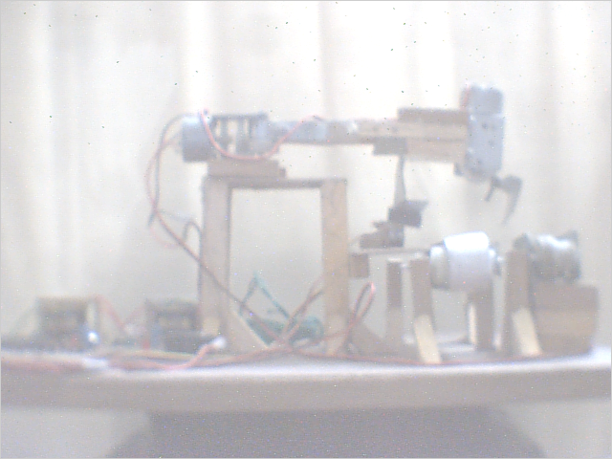
ON

AUTOMATED CONVEYOR BELT INTERFACED WITH PICK AND PLACE ROBOTIC ARM

A PROJECT BY THE STUDENTS OF

MAHARAJA AGRASEN INSTITUTE OF TECHNOLOGY
SECTOR – 22 ROHINI, DELHI

AFFILIATED TO
GURU GOBIND SINGH INDRAPRASTHA UNIVERSITY

STUDENT INITIALS

NAME ROLL NO

MANISH GAUTAM 0591483603

AREKH SHARMA 0631483603

MANISH SINGH 0481483603

BRAJ KISHORE BAITH 0601483603

YEAR: 4TH YEAR
BATCH: 2003-2007
GROUP: M1

COLLEGE: MAIT
BRANCH: MECHANICAL AND AUTOMATION ENGINEERING

ACKNOWLEDGMENT

We are very grateful and thankful to all the staff of
” MAHARAJA AGRASEN INSTITUTE OF TECHNOLOGY”
who guided us throughout the project and provided us their valuable suggestions & also provided the prominent knowledge to complete our project at different stages.
As a matter of fact we are specially thankful to
Mr. Aman Aggarwal (mechanical department),
Mr. Rajat Srivastava(electronics department),
Mr. O. P. Grover (dean mechanical department).

CERTIFICATE

This is to certify that

Manish Gautam roll no 0591483603

Arekh Sharma roll no 0631483603

Manish Singh roll no 0481483603

Braj Kishore Baitha roll no 0601483603

have done their project under the supervision and guidance of the college lecturers and guidance and knowledge have been provided to them at the various stages during their work.
We have carried out our project entitled “AUTOMATED CONVEYOR BELT INTERFACED WITH PICK AND PLACE ROBOTIC ARM” as a partial requirement for the award of degree of Bachelor of Technology in
MECHANICAL AND AUTOMATION by GURU GOBIND SINGH INDRAPRASTHA UNIVERSITY and is a record of bonafide work carried out and completed under the supervision and guidance during the academic session 2006-2007.

PROJECT GUIDE
MR. AMAN AGGARWAL
(MECHANICAL ENGINEERING DEPARTMENT)

AUTOMATED CONVEYOR BELT INTERFACED WITH PICK AND PLACE ROBOTIC ARM

M

A

E

2
0
0
7

Final project report submitted in partial fulfillment for the degree of Mechanical and Automation Engineering.

Submitted by



MANISHGAUTAM (ROLL NO-0591483603)
AREKH SHARMA (ROLL NO-0631483603)
MANISH SINGH (ROLL NO-0481483603)
BRAJ KISHORE BAITHA (ROLL NO-0601483603)

Under the guidance of
MR AMAN AGGARWAL
MECHANICAL AND AUTOMATION ENGINEERING
MAIT - 2007

AUTOMATED CONVEYOR BELT INTERFACED WITH PICK AND PLACE ROBOTIC ARM

Submitted by

MANISHGAUTAM (ROLL NO-0591483603)
AREKH SHARMA (ROLL NO-0631483603)
MANISH SINGH (ROLL NO-0481483603)
BRAJ KISHORE BAITHA (ROLL NO-0601483603)

MECHANICAL AND AUTOMATION ENGINEERING
MAIT - 2007

INDEX

- INTRODUCTION…………………………………
- PROBLEM DEFINITION………………………...
- LITERATURE REVIEW…………………………
- BLOCK DIAGRAM………………………………
- COMPONENTS USED……………………………
- DESIGN REQUIREMENTS………………………
- PROGRAMMING 8051………………………….
- CONCLUSION
- Applications
- Limitations
- SCOPE OF FUTURE WORK…………………….
- REFERENCES……………………………………..

INTRODUCTION

The production system is the collection of people, equipment and procedures organized to accomplish the manufacturing operations of a company.

The facilities in the production system are the factory, production machines and tooling, material handling equipment and the computer systems that control the manufacturing operations.

The product quantities produced in the factory can be divided into three ranges:

- Low production: quantities in the range of 1 to 100 units per year.
- Medium production: quantities in the range of 100 to 10000 units annually.
- High production: quantities over 100000 to millions of units annually.

Automation is the technology by which a process or procedure is accomplished without human assistance. It is implemented using a program of instructions combined with a control system that executes the instructions.

Basic elements of automated system
- Power to accomplish the process and operate the system.
- A program of instructions to direct the process.
- A control system to actuate the instructions.

Material handling is defined as the movement. Storage, protection, and control of materials throughout the manufacturing and distribution process including their consumption & disposal. The handling of the material must be done at the low cost in a timely manner, accurately, effectively & safely.

Fundamentals of automated assembly lines

A automated assembly system performs a sequence of automated assembly operations to combine multiple components into a single entity. The single entity can be final product or a sub assembly in a larger product. In many cases, the assembled entity consists of a base part to which other components are attached. The components are joined one at a time, so the assembly is completed progressively.

A selector is a device that acts a part filter, permitting only parts in the correct orientation to pass through. In correctly oriented parts are rejected back into the hopper.

An orientation is a device that allows the correctly oriented part to pass through, but orients the parts that were not oriented correctly first.

These selectors and can be used either on single cell machine or to a group of machines.

While being used on a group of machines that system is called as FMS (Flexible Manufacturing System).
DEFINING THE PROBLEM

Consider the problems like: -

- Material handling
- correct selection of the part
- maintaining the correct orientation of the part
- transferring the part from one location to another
- online inspection of the part

These problem appears different but are closely related to each other by the very fact that all these problems can be solved by a proper system that can detect a part and can decide upon the next step required to take with the part.

The material handling and its transportation throughout the plant requires the material to be handled (like) on a conveyer belt.

The inspection requires whether the finished/unfinished part to be further processed or to be rejected.

A particular inventory can hold a number of workpiece and the necessity of a workpiece at a particular workshop is randomly distributed. The system briefly described here will facilitate the automatic selection process of the raw material in the plant.

The same concept can be put into use at any where in the industry whether at the intermediate processing level of the material or at the finished product; it can even be utilized at the packaging department.

The sole aim of the project is to give an automatic selection power to the machines so that it can decide upon the right material to work with.

The problem taken up in this project is partly inspection and partly pick & place (transportation) from one place to other.

Consider a conveyer belt, an oncoming part is to be processed further but first it is required that the part should meet a particular descriptive feature let’s say height, otherwise it will not be worked upon.

Or consider a problem of a common conveyer belt handling a number of various parts in a plant, now it is required to transfer a part with some features on one line and others are required elsewhere.

The solution is a dedicated system that understands the incoming part and can take a decision whether to allow the part to be further processed or to reject the part and also to consider the part to be transferred to some other line.

In the FMS system this system is readily required to quickly decide upon the action on the incoming part.

CONVEYOR BELT

The mode of transport for the material in the industries can be equipped with the computational power to decide its start & stop.

Types of conveyers: -

- Roller & Skate Wheel Conveyers: - these conveyers have rolls or wheels on which the load rides. Loads must posses a flat bottom surface of sufficient area to span several adjacent rollers. Pallets, tote pans or cartons serve this purpose well.
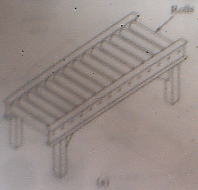
- In Roller Conveyers: - the pathway consists of a serious of tubes that are perpendicular to the direction of travel. Flat pallets or tote pans carrying unit loads are moved forward as the roller rotate. The roller conveyers can either be powered or non powered.

- Skate Wheel Conveyers: - they are similar in operation to the roller conveyers. Instead of rollers they use skate wheels rotating on shafts connected on a frame to roll pallets of tote pans or other containers along the pathways. The application is more or less similar to the roller conveyers.
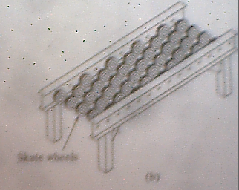
- Belt Conveyers: - belt conveyers are consist of continuous loop: half its length is used for delivering materials, and the other half is the return run. The belt is made of reinforced elastomer (rubber) so that it posses high flexibility but low extensibility. At one end of the conveyer is a drive roll that powers the belt.

The conveyor belt being driven by ordinary but powerful motors is equipped with sensors to detect the location of the belt.

The project here requires ordinary conveyor belt with the drive to the belt being given by a simple dc motor. The main point to be considered here is the height of the conveyor belt which should to be taken into account programming the robot.
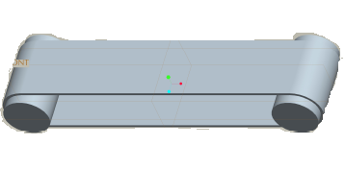
Conveyor

Operation types of conveyers: -

- Continuous Conveyers: - moves at constant velocity along the path. They include belt, roller, skate-wheel, overhead trolley, and slat conveyers.

- Asynchronous Conveyers: - operate with stop & go motion in which the loads usually contained in carriers, move between stations and then stop and remain at station until released.
ROBOTIC ARM
CONVEYER BELT
GRIPPER
CONTROLLER
IR SENSOR
MAGNETIC REED SENSOR
BLOCK DIAGRAM OF PROPOSED PROJECT

MICROCONTROLLER 8051 & ITS CONTROL
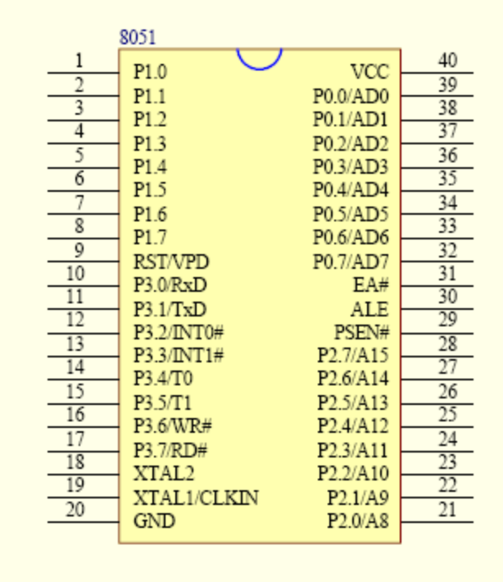
The 8051
The 8051 developed and launched in the early 80`s, is one of the most popular micro controller in use today. It has a reasonably large amount of built in ROM and RAM. In addition it has the ability to access external memory.
The generic term `8x51` is used to define the device. The value of x defining the kind of ROM, i.e. x=0, indicates none, x=3, indicates mask ROM, x=7, indicates EPROM and x=9 indicates EEPROM or Flash.
A note on ROM
The early 8051, namely the 8031 was designed without any ROM. This device could run only with external memory connected to it. Subsequent developments lead to the development of the PROM or the programmable ROM. This type had the disadvantage of being highly unreliable.
The next in line, was the EPROM or Erasable Programmable ROM. These devices used ultraviolet light erasable memory cells. Thus a program could be loaded, tested and erased using ultra violet rays. A new program could then be loaded again.
An improved EPROM was the EEPROM or the electrically erasable PROM. This does not require ultra violet rays, and memory can be cleared using circuits within the chip itself.
Finally there is the FLASH, which is an improvement over the EEPROM. While the terms EEPROM and flash are sometimes used interchangeably, the difference lies in the fact that flash erases the complete memory at one stroke, and not act on the individual Cells. This results in reducing the time for erasure.

Different Microcontrollers In Market.

- INTEL These are the first to manufacture microcontrollers. These are not as sophisticated other microcontrollers but still the easiest one to learn. Intel 8051 is CISC architecture which is easy to program in assembly language and also has a good support for High level languages. The memory of the microcontroller can be extended up to 64k. The 8051 microcontroller is in the field for more than 20 years.

- Atmel Atmel’s AVR microcontrollers are one of the most powerful in the embedded industry. This is the only microcontroller having 1kb of ram even the entry stage. But it is unfortunate that in India we are unable to find this kind of microcontroller.

- PHILIP Philips‘s 8051 derivatives has more number of features than in any microcontroller. The costs of the Philips microcontrollers are higher than the Atmel’s

The 8051 doesn’t have any special feature than other microcontroller. The only feature is that it is easy to learn. Architecture makes us to know about the hardware features of the microcontroller. The features of the 8051 are

- 4K Bytes of Flash Memory
- 128 x 8-Bit Internal RAM
- Fully Static Operation: 1 MHz to 24 MHz
- 32 Programmable I/O Lines
- Two 16-Bit Timer/Counters
- Six Interrupt Sources (5 Vectored)
- Programmable Serial Channel
- Low Power Idle and Power Down Modes

Pin Function of IC 89c51.

- Supply pin of this IC is pin no 40. Normally we apply a 5 volt regulated dc power supply to this pin. For this purpose either we use step down transformer power supply or we use 9 volt battery with 7805 regulator.

- Ground pin of this IC is pin no 20. Pin no 20 is normally connected to the ground pin (normally negative point of the power supply.

- XTAL is connected to the pin no 18 and pin no 19 of this IC. The quartz crystal oscillator connected to XTAL1 and XTAL2 PIN. These pins also need two capacitors of 30 pf value. One side of each capacitor is connected to crystal and other pin is connected to the ground point. Normally we connect a 12 MHz or 11.0592 MHz crystal with this IC. But we use crystal upto 20 MHz to this pins

- RESET PIN Pin no 9 is the reset pin of this IC. It is an active high pin. On applying a high pulse to this pin, the micro controller will reset and terminate all activities. This is often referred to as a power on reset. The high pulse must be high for a minimum of 2 machine cycles before it is allowed to go low.

- PORT0 Port 0 occupies a total of 8 pins. Pin no 32 to pin no 39. It can be used for input or output. We connect all the pins of the port 0 with the pullup resistor (10 k ohm) externally. This is due to fact that port 0 is an open drain mode. It is just like a open collector transistor.

- PORT1. ALL the ports in micrcontroller are 8 bit wide pin no 1 to pin no 8 because it is an 8 bit controller. All the main register and SFR all is mainly 8 bit wide. Port 1 is also occupies 8 pins. But there is no need of pull up resistor in this port. Upon reset port 1 acts as a input port. Upon reset all the ports act as a input port

- PORT2. Port 2 also have a 8 pins. It can be used as an input or output. There is no need of any pull up resistor to this pin.

- PORT 3. Port3 occupies a total 8 pins from pin no 10 to pin no 17. It can be used as input or output. Port 3 does not require any pull up resistor. The same as port 1 and port2. Port 3 is configured as an output port on reset. Port 3 has the additional function of providing some important signals such as interrupts. Port 3 also use for serial communication.

- ALE ALE is an output pin and is active high. When connecting an 8031 to external memory, port 0 provides both address and data. In other words, the 8031 multiplexes address and data through port 0 to save pins. The ALE pin is used for demultiplexing the address and data by connecting to the IC 74ls373 chip.

- PSEN. PSEN stands for program store enable. In an 8031 based system in which an external ROM holds the program code, this pin is connected to the OE pin of the ROM.

- EA. EA. In 89c51 8751 or any other family member of the ATMEL 89c51 series all come with on-chip ROM to store programs, in such cases the EA pin is connected to the Vcc. For family member 8031 and 8032 is which there is no on chip ROM, code is stored in external memory and this is fetched by 8031. In that case EA pin must be connected to GND pin to indicate that the code is stored externally.

Power supply:
8051 can handle power supply of 3.5 volts to 7 volts with no problem. Always use a Decoupling Capacitor between the Power supply and the Ground. Decoupling capacitors are used to avoid the spikes. Pin 40 is for VCC and Pin 20 is for Gnd.

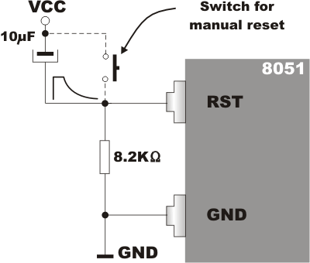
Reset Circuitry:

As soon as you give the power supply the 8051 doesn’t start. You need to restart for the microcontroller to start. Restarting the microcontroller is nothing but giving a Logic 1 to the reset pin at least for the 2 clock pulses. So it is good to go for a small circuit which can provide the 2 clock pulses as soon as the microcontroller is powered.

This is not a big circuit we are just using a capacitor to charge the microcontroller and again discharging via resistor.
Architecture

Architecture is defined as the internal basic design on which the microcontroller or the processor is designed.

It is the architecture of the controller that drives the functions assigned to it

Architecture is must to learn because before learning new machine it is necessary to learn the capabilities of the machine. This is some thing like before learning about the car you cannot become a good driver. The architecture of the 8051 is given below.

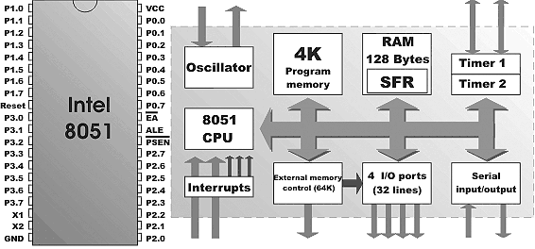

Embedded System Through 8051.

In this project we show that how we convert simple robotic arm into a fully automatic robotic arm. After putting a automation logic it is very useful for industrial automation.
In this project we use many step to control automation system.

- CONVEYER BELT SYSTEM.

- INFRA RED SENSOR INTERRUPTION LOGIC.

- AUTO GRIPPER SYSTEM

AUTO MOVE ROBOTIC ARM..

Conveyer Belt System.

In this project we use slow speed dc gear motor to run the conveyer belt. Start signal is provided by the microcontroller circuit. In the main unit when the supply unit is on, then conveyer belt is not start automatically. Start switch of the conveyer belt is provided by the microcontroller.

First work of the microcontroller is to start the conveyer belt after pressing a switch and then to monitor the infra red sensor for reflection.

After conveyer belt starts then our infra red sensor monitors the oncoming object. If the object is suitable for the machine then object moves on the belt but if the object is above height then infra red sensor sense the signal with the help of reflection from the object. When infra red sensor reflect the rays then machine sense the signal through photodiode. Photodiode and infra red sensor connected as pair on a certain height and detects the reflected signal.

Now conveyer is stopped automatically and gripper connected above the sensor is activated to grip the object. For the gripper we use second dc gear motor. Control signal to grip the object is provided by the microcontroller itself.

After gripping the object third motor starts and move the robotic hand to other side, after some delay third motor is stop and now gripper opens itself and releases the object in the basket. After releasing the object, third motor again starts & moves the robotic hand to reverse side with the same delay and start the conveyer belt automatically

MAIN part of this project is microcontroller that provides a signal to the robotic arm to start the conveyer belt then sense the reflection, if reflection is there then stop the conveyer belt, and after stopping the conveyer belt grip the gripper, move the robotic hand, drop the object in basket and again move the conveyer belt. This entire signal is provide by the microcontroller.

We wrote a program for this IC. Program is to be written in the ASM codes and then this code is converted into hex code with the help of the assembler. In this project we use 8051 IDE software to assemble the ASM codes into HEX code. Once the code is converted into HEX code then we transfer this code in the blank IC with the help of program kit connected with the computer.

Let Us See The Architecture In Detail.

- Ports
- Timers
- Interrupts

Ports

Ports used to communicate with the outside world.

8051 is having 4 ports & each has 8 I/O Pins. Simplest I/O Port in all microcontroller.

Port0, Port2 can be used for the External Addressing. If our code has exceeded the 4kb then we need to use extra ROM & RAM. For addressing the extra memory chips we need to loose our Port 0 & port 2.

Port3 is one of the important ports; this has the serial port, timers and interrupts pins.

Port1 is free can be used only as Port!!

In this project we use three dc motor to run the conveyer belt and robotic arm. One motor to run the conveyer belt and second motor is for the gripper and third motor is for the hand movement,

Circuit Working:

Pin no 40 is connected to the positive supply. . 5 volt regulated power supply is provided to the pin no 40. Pin no 9 is connected to the reset pin. On this pin we connect one 10 mfd capacitor and 10 k ohm resistor. With the help of this capacitor and resistor we force the micro controller to start up from the 0000h location when start. Start switch is connected to the pin no p1.0. On this pin we use push to on switch. When we press this switch then pin no p1.0 become more negative and circuit start and conveyer belt is on move. Conveyer belt is start because p2.0 and p2.1 pins are give a pulse to the H bridge circuit to give a voltage to the dc motor. When dc motor is on then conveyer belt is on with the help of H-bridge circuit. Now program is shifted to infra red sensor, if there is any obstruction against infra red led then infra red sensor sense the signal and at this time port p1.1 is more negative and circuit stop the conveyer belt. When conveyer belt is stop then second motor is switch on to grip the object. When object is gripped then third motor is on and move the object to the basket, third motor is connected to the p2.4 and p2.5. One buzzer is connected to the port p1.3, this buzzer is on when infra red sensor sense the signal. .

Control of motor is done by the H bridge circuit. In the H bridge circuit we use two NPN transistors and two PNP transistors. With the help of this two NPN transistor and two PNP transistors we control the direction of the motor.

H bridge is interface with the microcontroller with the help of opto-coupler circuit., Opto-coupler circuit not only interface the microcontroller with the H bridge but also provide a electrical isolation between microcontroller and dc motor circuit.

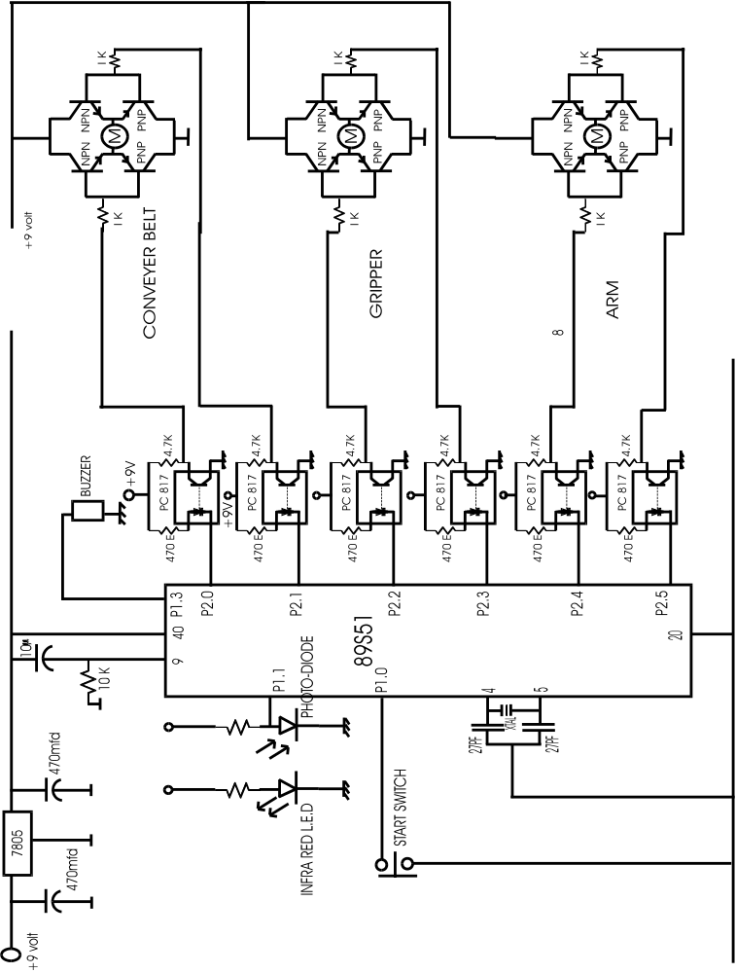

PROGRAM CODE & LOGIC FOR CONTROLLER
org 0000h
ORG MEANS ORIGION, ON THIS POINT WE START THE PROGRAM CODE, WHEN MICROCONTROLLER IS ON THEN PROGRAM IS RESET AUTOMATICALLY AND START FROM THE 0000 LOCATION.
sjmp main

main:

jnb start,s1
sjmp main

s1:
clr p2.0 ; motor1 for conveyer belt
setb p2.1 ; motor1
jnb input,s2 ; input for the ir sensor
sjmp s1

s2:
setb p2.0 ; stop the motor
setb p2.1 ; stop the motor1( conveyer belt)

clr p1.3 ; buzzer on

acall delay1
setb p1.3 ; stop buzzer

clr p2.4 ; start motor3 forward
setb p2.5 ; start motor3 forward
acall delay2
setb p2.4
setb p2.5

setb p2.2 ; start motor 2 reverse
clr p2.3 ; start motor 2 reverse

acall delay1
setb p2.2
setb p2.3
setb p1.3 ; stop the alarm

D1: CLR p2.4
SETB p2.5
JB P1.2,D2
SJMP D1

acall delay2
D2: CLR p2.4
setb p2.5

Run conveyer belt
Is material detected?
Stop the conveyer belt
Run gripper motor cw.
Call delay
Stop gripper motor
Run arm motor cw.
Call delay
START
Stop arm motor
Run gripper motor ccw.
Stop gripper motor
Call delay
Run arm motor ccw.
Is arm at origin?
Stop arm motor
1
1
Yes

No
No
Yes
Yes
2
2

ORIGINAL PROGRAM

MAIN: ORG 000H
SETB 80H ; RESET IR
SETB 84H ; RESET MAGNETIC SENSOR
SJMP STEP1

DELAY: MOV R5,#FFH
MOV R6,#22H
AGAIN: DJNZ R5,AGAIN
DJNZ R6,AGAIN
RET

STEP1: CLR 90H ; CONVEYER START
CLR 80H
JNB 80H,STEP2 ; IR DETECT
SJMP STEP1
STEP2: SETB 90H ; CONVEYER STOP
CLR 82H ; BUZZER ON
SETB 83H
ACALL DELAY
SETB 82H ; BUZZER OFF
CLR 92H ; M2 START FORWARD
SETB 93H
ACALL DELAY
SETB 92H ; M2 STOP
CLR 94H ; M3 START FORWARD
SETB 95H
ACALL DELAY
ACALL DELAY
SETB 94H ; M3 STOP
SETB 92H ; M2 START REVERSE
CLR 93H
ACALL DELAY
SETB 93H ; M2 STOP
STEP3: SETB 94H ; M3 START REVERSE
CLR 95H
;CLR 84H
JB 84H,STEP3 ; MAGNETIC SENSOR FOR ARM
SETB 95H ; M3 STOP
SJMP MAIN
END

BURNER FOR THE 8051 CHIP

BlowIT 2051 is simplest possible burner for AT89C2051 Flash Microcontroller. It is “as simple as possible” only designed for fast and dirty jobs, where you need to get going and fast. Only very few components are required. Functionality is minimal, only erase and program are implemented.

Power Supply

Basically +5 and +12 are available inside the PC on the floppy/HD power cable as example. Well use them at your own risk. A simple power supply can be buildt using 7812 and 7805.
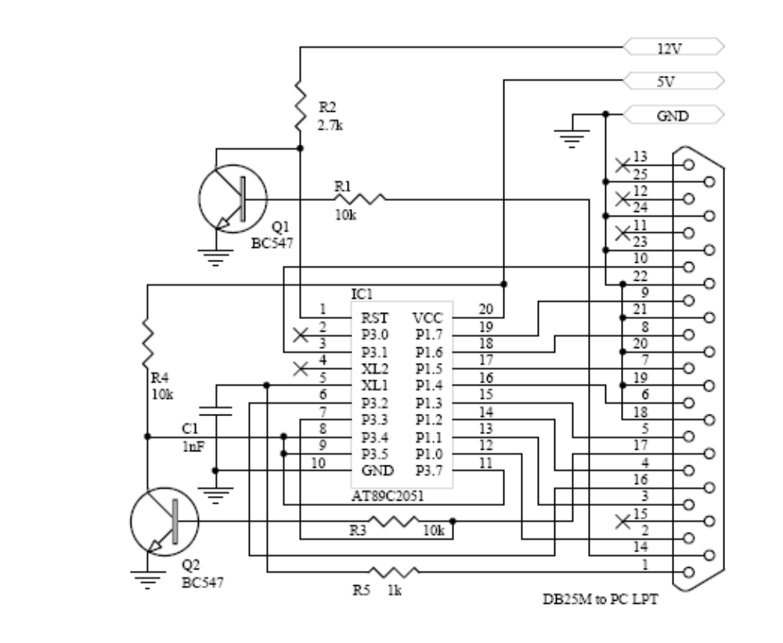
PROCEDURE

- At first the required wooden structure was given the shape

  - The wooden base structure 18”*12” was made out of plywood.
  - Than an ordinary wood piece carved to be as a robotic arm of about 6”.
  - A small table like structure was also created to accommodate the operation of the conveyer belt.
  - Another tabular structure was raised to accommodate the robotic arm and its drive motors.

- All the moving parts like the arm of the robot was created by fixing the D.C. geared motor at the one end of the arm (wooden rod) to actuate the gripper. The gripper is actuating in both fwd. rev. direction.

- The gripper was made out of the sheet metal and was connected to the end of the drive of the D.C geared motor, which was fixed to the robotic arm.

- The conveyer belt set up was put into place along with its drive motor.

- The robotic arm was than connected on its stand over a third D.C. geared motor to supply the whole rotation (fwd. as well as rev.) to the robotic arm along with its gripper as per requirement.

- The IR (including IR LED & a photo diode) detector was placed at a suitable distance on the conveyer belt.

- The magnetic reed switch was positioned to the home position of the robotic arm, such that the magnet that is placed on the robotic arm is as close to the reed switch as possible but sufficiently far away to actuate the reed switch when robotic arm is well over the conveyer belt.

- The circuit on the bead board was than prepared separately before actually assembling it to the rest of the hardware

- 12 n-p-n BJT’s were taken and were connected in a group of 4 each to create the H-bridge circuit to control the direction of the of the D.C. motor

- Then to isolate the H-bridge circuitry voltage to that of the D.C. motor operating voltage the opto-coupler were connected with the H-Bridge. A total of 6 opto-coupler were used (2 for each motor * 3).

- Then the seat of the 40 pin 8051 microcontroller was soldered to the bead board.

- With the pins XTAL1 & XTAL2 of the microcontroller a 12 MHz crystal (for timing the machine cycle as well as its delay loop) was also connected.

- A reset circuitry used to reset the microcontroller was connected to the reset pin of the microcontroller to set the logic 1 to the pins of microcontroller.

- To supply the power to the logic circuit, a step down center –tapped transformer with a full wave rectifier circuit including a filter circuit was used (to eliminate the A.C. pulse).

- The potential supplied by the step down transformer is around 9V; to control the limit of this voltage to 5V for the microcontroller to work fluctuation freely an electronic voltage regulator was used along with the full wave rectifier.

- Another transformer (step down) also with a proper rectification was connected to supply the power to the three D.C. motors.

(The power supplies the electronic circuit & that of the 3 D.C. motors are intentionally kept separate.)

- Meanwhile the H-bridge was connected to the requisite ports of the microcontroller & a buzzer was also connected as a warning source to remind the operation of the project.

- To protect the various circuit components like IR, H-bridge, and PORT0 (to be supplied with external pull down registers), suitable resisters were used.

- All the three motors, a buzzer, the reed switch & the IR detector was connected to the require port via H-bridges.

- On the Rigel’s microcontroller assembler program the program was written as per the proposed algorithm.

(The program was generated as the .asx file. The reason for such a file extension is that the assembler can recognize this file extension as is capable of generating the required .hex file to be fed to the microcontroller)

- The program was compiled & the generated hex file was burned to the 8051 microcontroller by using the BlowIT 8051 burner.

- The last step is to place the microcontroller on the seat.

- Test run was made and the generated problems of the hardware as well as of software were sorted out.

Future scope

The zest of our project lies in the flexibility of the robotic arm

- Increasing the degree of freedom

In the project the robotic arm used here is of 2 degree of freedom with capability of working only in one single frame and that’s to in limited area, by increasing the D.O.F. of the robotic arm to about 6 we can tremendously increase the workspace of the robot.

Flexibility of the robot to cover up its maximum workspace is absolute must to put into severe consideration for the future development.

Also by using a closed loop control for automation will further increase the accuracy and precision quality of our project.
- User defined programming.

The system used here has a fixed type programming in other words the software program is one time fixed, any change required in the further processing is not easy to overcome. This problem is likely and mandatory to be taken up in the future consideration work. The program used for controlling the robot should be of dynamic type or let’s say user defined.

To further increase the capability of robot in taking self decision artificial intelligence is the scope of future work that can provide the robot the capability to take decision in case of collision detection and its avoidance, obstruction detection and to decide the shortest alternate path if any collision takes place in the proposed path. Artificial intelligence will also be very useful for the safety of the operator handling the machine

- vision system

The vision just like human eyes but with a finer capability to capture the details of the object can be used with such a machine system. This will be a great aid in completely atomizing the object detection and its inspection on line.

The machine with a capacity to recognize the objects will require a minimum human intervention during the inline processing of a product.

While the inspection capability will facilitate in curtailing the inspection investment and time consumption in the inspection required.

With a dedicated vision system; the assembly of various components in a production line can be adapted very efficiently.
- Intelligent gripper
The most critical aspect of any robotic arm is in the design of the manipulator or gripper. Another improvement in the gripper design is viable option.
A robotic arms usefulness and functionality is directly related to the arms ability to sense and successfully manipulate its immediate environment. We can develop such a gripper assembly to include the following critical design features:
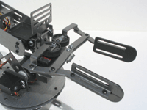

- The gripper assembly can contain an integrated, adjustable electronics stand located above the gripper assembly to accommodate an array of CCD cameras, infrared sensors and other sensing electronics.
- The ends of the gripper should be designed as rounded for an even gripping surface area.
- The rounded gripper ends can conveniently accommodate the "Flexiforce" pressure sensor for precise gripper pressure measurement and control.
- A cross-linked polyethylene foam use should be encouraged to line the inside of the gripper surface for maximum grip adhesion.

The simulation program allows to create the programs for
training robot SLR 1500 either by executing RAMAS language
commands or by manually teaching the robot movement. Such a
program can be later edited in the program editor.
Since this simulation program works with programming
language RAMAS, which is used in majority of robots of
Slovak production it is possible to use it for teaching of
industrial robots programming. The simulation is realised in
axonometric view and respects the visibility of the edges and
surfaces, which helps to visualise the concrete situations.
After the development of hardware control system for robot
SLR 1500 is finished it is possible to extend this simulation
software with communication module. This would allow to
send the created, with a simulation verified programs directly to
the memory of the control system via serial interface.

